CYNGOR TREF MAESTEG  Swyddfeydd y Cyngor  Stryd Talbot  Maesteg CF34 9BY  Teleffon: 01656 732631  Ebost: clerk@maestegcouncil.org | 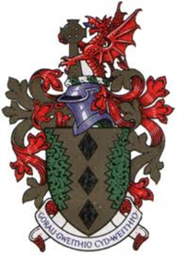 | MAESTEG TOWN COUNCIL  Council Offices  Talbot Street  Maesteg CF34 9BY  Telephone: 01656 732631  Email: clerk@maestegcouncil.org

12th July 2022
Dear Councillor,

You are summoned to attend a HYBRID EXTRAORDINARY meeting of the TOWN COUNCIL to be held in the Council Chamber and remotely via Microsoft TEAMS on THURSDAY, 14TH JULY 2022 at 6.00pm.

Yours sincerely

Siân Teisar
Clerk to the Council

AGENDA
- To receive Apologies & Members’ Declaration of Interest.
- To receive the Internal Auditor Report
- To complete the Annual Return 2021-22
- To discuss the membership of the Personnel Committee and Chair
- To discuss the renewal of the Van insurance

……………………………………………

Any member of the public wishing to attend is to send their name and email address to the Town Clerk at clerk@maestegcouncil.org where you will be sent a link by email on the day of the meeting

