CYNGOR TREF MAESTEG  Swyddfeydd y Cyngor  Stryd Talbot  Maesteg CF34 9BY  Teleffon: 01656 732631  Ebost: clerk@maestegcouncil.org | 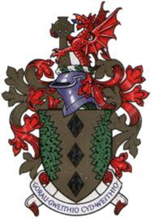 | MAESTEG TOWN COUNCIL  Council Offices  Talbot Street  Maesteg CF34 9BY  Telephone: 01656 732631  Email: clerk@maestegcouncil.org

23rd November 2022

Dear Councillor,

You are summoned to attend a HYBRID EXTRAORDINARY meeting of the TOWN COUNCIL to be held in the Council Chamber and remotely via Microsoft TEAMS on TUESDAY , 29th NOVEMBER 2022 at 6.00PM

Yours sincerely

Siân Teisar
Clerk to the Council

AGENDA

- To receive Apologies & Members’ Declaration of Interest.
- To discuss the email received from Cllr Paul Davies

……………………………………………

