CYNGOR TREF MAESTEG  Swyddfeydd y Cyngor  Stryd Talbot  Maesteg CF34 9BY  Teleffon: 01656 732631  Ebost: clerk@maestegcouncil.org | 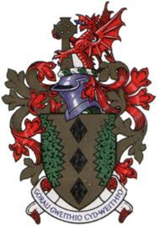 | MAESTEG TOWN COUNCIL  Council Offices  Talbot Street  Maesteg CF34 9BY  Telephone: 01656 732631  Email: clerk@maestegcouncil.org

8th December 2022

Dear Councillor,

You are summoned to attend a HYBRID EXTRAORDINARY meeting of the TOWN COUNCIL to be held in the Council Chamber and remotely via Microsoft TEAMS on TUESDAY , 12th DECEMBER 2022 at 6.30PM

Yours sincerely

Siân Teisar
Clerk to the Council

AGENDA

- To receive Apologies & Members’ Declaration of Interest.
- To discuss the telephone conversations the Mayor had with the 2 companies that provides quotes for replacing fire doors to rear of the building
- To discuss amending the S137 Policy for organisations who are providing warm hubs during the Winter
- To discuss adding funds to Members Expenses & Van due to current overspend
- To Agree the Draft Budget for 2023-24
- To set the Precept for 2023-24

……………………………………………

