CYNGOR TREF MAESTEG  Swyddfeydd y Cyngor  Stryd Talbot  Maesteg CF34 9BY  Teleffon: 01656 732631  Ebost: clerk@maestegcouncil.org | 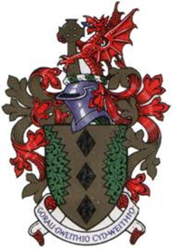 | MAESTEG TOWN COUNCIL  Council Offices  Talbot Street  Maesteg CF34 9BY  Telephone: 01656 732631  Email: clerk@maestegcouncil.org

9th February 2023

To Members of the Personnel Committee – AR Davies (Chair)
C Knight, A James, L Thomas and G Williams

Dear Councillor,

You are summoned to attend a Personnel Committee to be held in the Council Chamber and remotely via Microsoft TEAMS on THURSDAY 16TH February 2023 at 6.30pm.

Yours sincerely

Sian Teisar
Clerk to the Council

AGENDA

- To receive apologies & Declaration of Interest.
- To go into committee to discuss below confidential items
- To discuss Pay scales of other T&CC’s Clerk and Deputy Clerks
- To discuss any other personnel issues

------------

