CYNGOR TREF MAESTEG  Swyddfeydd y Cyngor  Stryd Talbot  Maesteg CF34 9BY  Teleffon: 01656 732631  Ebost: clerk@maestegcouncil.org | 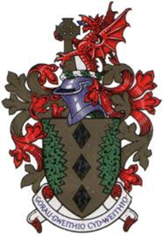 | MAESTEG TOWN COUNCIL  Council Offices  Talbot Street  Maesteg CF34 9BY  Telephone: 01656 732631  Email: clerk@maestegcouncil.org

12th April 2023

To Members of Property and H&S Committee Maesteg Town Council
Cllrs: I Williams (Chair), F Abedalkarim, P Jenkins, R Martin and R Penhale-Thomas

Dear Councillor,

You are summoned to attend a remote meeting of the Property and H&S Committee to be held Hybrid via Microsoft TEAMS and in Council Chamber on MONDAY, 17th APRIL 2023 at 6.30pm.

Yours sincerely

Siân Teisar
Clerk to the Council

AGENDA

- To receive apologies & Members’ Declaration of Interest
- To discuss installing a hot water tap in the disabled toilet and converting the sink in the kitchen from a waste disposal sink to a normal sink in the kitchen
- To discuss options for replacing the car park toilet in July
- To update the Asset Register
- To discuss a policy for the hire of gazeboes to community groups and individuals
- To discuss the possibility of converting the outside store room into a public toilet

……………………………………………

