MAESTEG TOWN COUNCIL
CORRESPONDENCE – 4th MARCH 2025

NEWSLETTERS / FLYERS / BRIEFING NOTES/ CONSULTATIONS
Emailed to all Councillors for information:
- BCBC Letter from the Leader: Meeting on 21 January with T&CC's -Future of local service delivery, co-producing with our local communities OVW: 2025 TRAINING DATES - JANUARY - MARCH 2025
- BCBC: Mayor's Citizenship Awards 2025
- BCBC: News bulletin for councillors- Maternity and neonatal services set to return to Princess of Wales Hospital
- Boundary Commission: 2025 Electoral Review Programme
- St David’s Day service invitation to all Cllrs - St. David’s Church Maesteg on Saturday 1st March, 10am.
- letter received in post today regarding litter
- AWEN - Llynfi Valley Welsh Film Festival
- OVW - Latest Development Notes from One Voice Wales
  - Organising a successful event
  - Asset Register
  - Meetings Administration
- IRP – Annual Report 2025-2026
- BCBC - News bulletin for councillors: Welsh Guards to join St David’s Day Parade

REFERRALS
03/02/25: Coegnant road, Caerau, - Fly tipping
03/02/25 Response: We are aware of the above from a previous report.

21/02/25: Lane leading to Bronfair Allotments - Himalayan Balsam growing in lane leading to allotments, asked if council could cut it back as it’s their land. Running along side the allotments is a private road/ lane also full of Himalayan Balsam, it belongs to the farm at the end of the lane, they use it for access, this is blowing seeds into the allotments, spreading it every where, badly affecting the bottom plots, contaminating everywhere. The allotments is Council owned land. Can they help with this issue ? Could they insist the land owner cuts back/ pulls up this prolific weed ?
21/02/25 Response: As the Himalayan is growing in the lane this would be a Highways issue for the adopted part. I have copied in talktous to log a call for highways
Still waiting for a response from highways

MARKET SQUARE – EGG
13/02/25 The egg in the market square that is supposed to open up but has been idle for years is having some works done to it today. Theres a lot of workers from BCBC out and I spoke with one of the engineers and he confirmed that the electrics under the square aren’t in the best shape with too much water getting in.

I understand that this topic comes up fairly frequently and many members are approached by the public asking its use and purpose but at first inspection the guys suspect it may be taken away.

I did speak briefly with the town centre manager several months ago and he said that they will be reviewing the electrics in the market square as the ones in the floor are experiencing issues.

REQUEST – CLLR K DUGGAN – BENCHES ON CYCLE TRACK
the state on some of the log benches across the cycle track from the Dyffryn hotel in Nantyffyllon all the way up to the spirit of the Llynfi woodland. Is there the possibility of replacing these if there is a budget for the rights of way committee. There also used to be a bench located near the top of Evans Terrace which is no longer there i believe if that may be worth replacing also. These benches have been widely used and I feel are an asset to the routes for those wishing to rest on a walk

Also with the consultation going on with the possibility of the merger with llan middle, would it be worth discussing the impact this may have when the councils merge on the digital rights of way if this gets accepted.

List of benches with What3Words locations provided:
 | What3Words location |  | Location | Notes
1 |  | 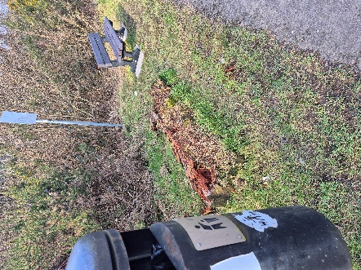 |  | Advised this has already been replaced, old bench being left to decompose
2 | economies.client.slurs | 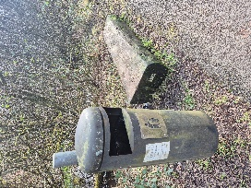 | NCN885 to the right of Bangor Terrace | Nantyffyllon Ward
3 | region.fence.clubs | 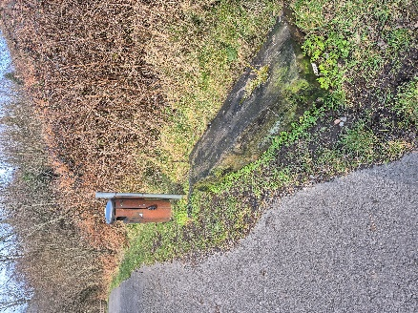 | NCN885 to the right of Coegnant Rd | Nantyffyllon Ward
4 | family.brink.riverside | 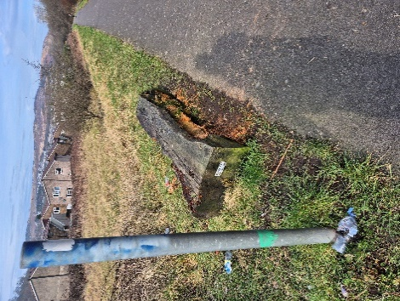 | NCN885 to the left of BMX track | Nantyffyllon Ward

N.B. the bench that was replaced in November 2024 to a composite bench cost: £585.00 + VAT

BUILDING WORKS – ADDITIONAL WORK
Dawsons are only working to the letter of the maintenance and repair schedule and are not incorporating re-painting of walls / skirting etc. they have provided the following quotes for additional works N.B. all quotes ex.VAT:

Q4202g | Ground and first floor rooms adjacent lift entrance. Rub down prepare and redecorate timber skirting and ceiling coving within the areas re-rendered around window frame.  As an off set to this the three windows on the East elevation do not need the mastic seal applied on the other elevations. I will delete this cost in the next valuation.  Moving forward we are planning to remove the scaffold from the chimney next week. This will allow us to check the roof before dismantling the full scaffold the following week. | £654.00
Awaiting further quotes for each room within the building, hopefully this will be received before full council

MARKET SQUARE – ASB
We’ve just concluded a rights of way committee meeting, I have had to contact the Police once again as there are youths in the market square and town causing grief. Just an FYI if anyone receives reports – its already been reported through 999 as previously recommended by the local Sgt.

REQUEST – LLAN MIDDLE CC
We are considering the installation of a dog bin on both Llan Road, Cwmfelin and Llan Road, Llangynwyd. In light of this, we kindly seek the Town Council's approval for your maintenance officer to service these bins. We understand that this will incur a cost, which we are prepared to cover

REQUEST – MAESTEG CELTIC BOWLING CLUB 100 YEAR ANNIVERSARY
I am writing on behalf of Maesteg Celtic Bowls Club. The club will be celebrating its Centenary in 2026 which coincides with Maestegs 200 year anniversary.

We will be hosting many clubs including the county finals. To showcase the club in the best light we need to replace the rotting timbers around the Ditch, and the renewal of the infill. This at a cost of approximately £3,000

We have twelve months to achieve this and other improvements. Our request to the Council is for any financial help they can provide Would be greatly appreciated.

Clerk has supplied the club with S137 Application form.

CiLCA QUALIFICATION
Clerk has passed CiLCA qualification – awaiting Ascentis for ratification
REQUEST TO HOLD A BEGINNERS CERAMIC SCULPTURE CLASS
Email received requesting to use the Town Council as a venue to host a beginners ceramic sculpture class.

25/02/2025

