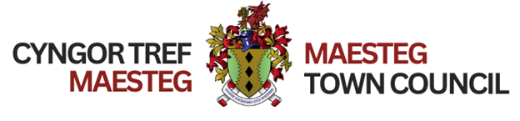
TOWN COUNCIL COMMUNITY AWARDS
NOMINATION FORM 2024

I am nominating for the following award (please tick appropriate box)

1. Young Achiever of the Year
2. Services to Youth and Education
3. Community Champion
4. Services to Voluntary Work
5. Local Environmental Champion
6. Gardener of the Year
7. Good Neighbour
8. Young Carer
9. Charity / Fund Raiser
10. Mental Health and Wellbeing Champion
11. Sports & Leisure Award
12. Outstanding Achievement Award

Please use a separate form for each nominee

Name of Nominee
Address of nominee
Postcode
Email address

Reasons for nomination:- (Please include as much information as you can as to your reason for nominating, continue on a separate sheet if this space is not enough)

Proposer Name
Signature
Date:

Completed nomination forms should be returned to:
Maesteg Town Council Offices,
Talbot Street
Maeasteg
CF34 9BY

Or emailed to: clerk@maestegcouncil.org

Closing Date - Midday Wednesday 28th February 2024

Enquiries Tel: 01656 732631

